**PROOF OF TESTING**

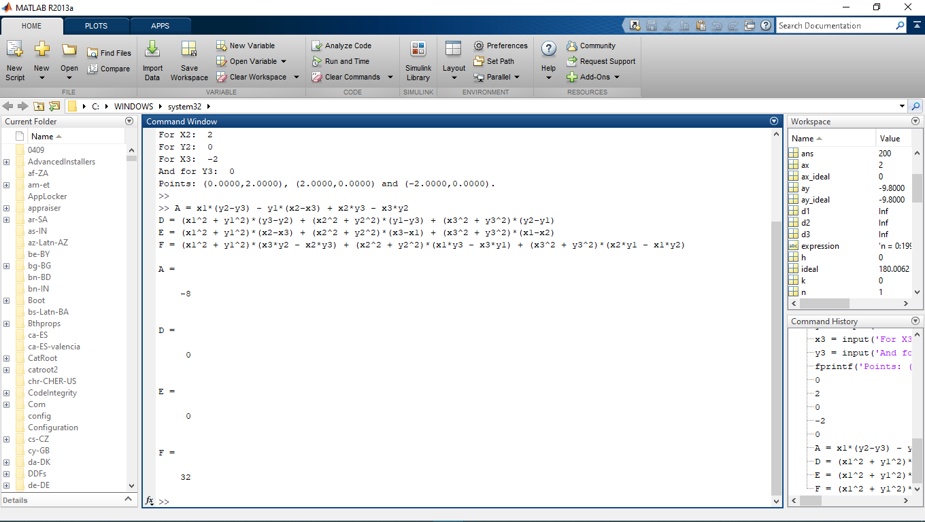**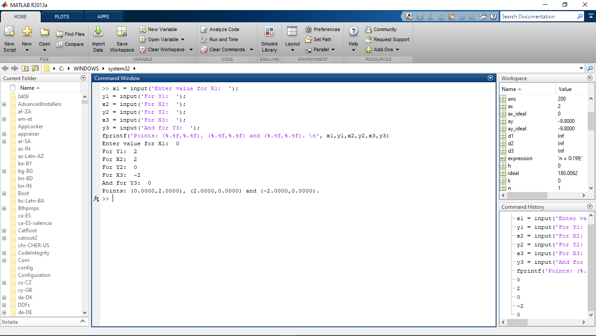MATLAB Problem 2**

**Values of D, E and F**

**Input three points**

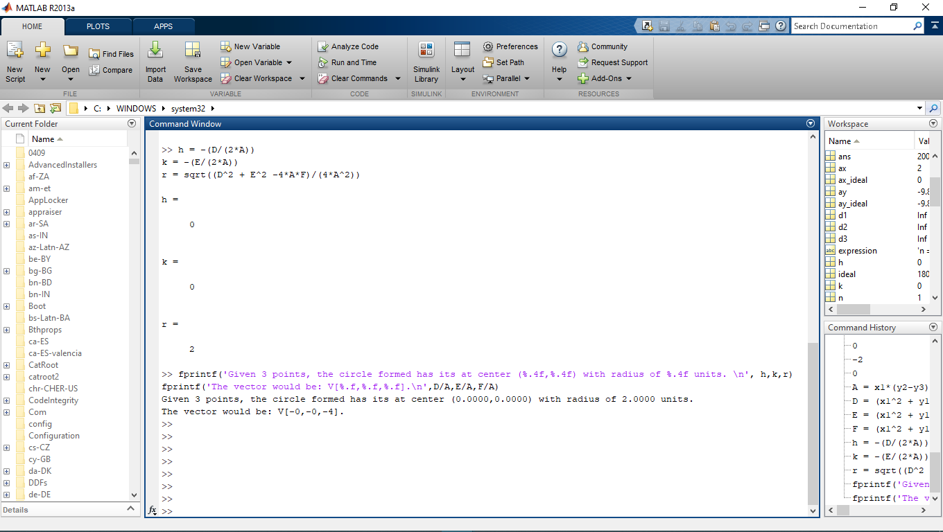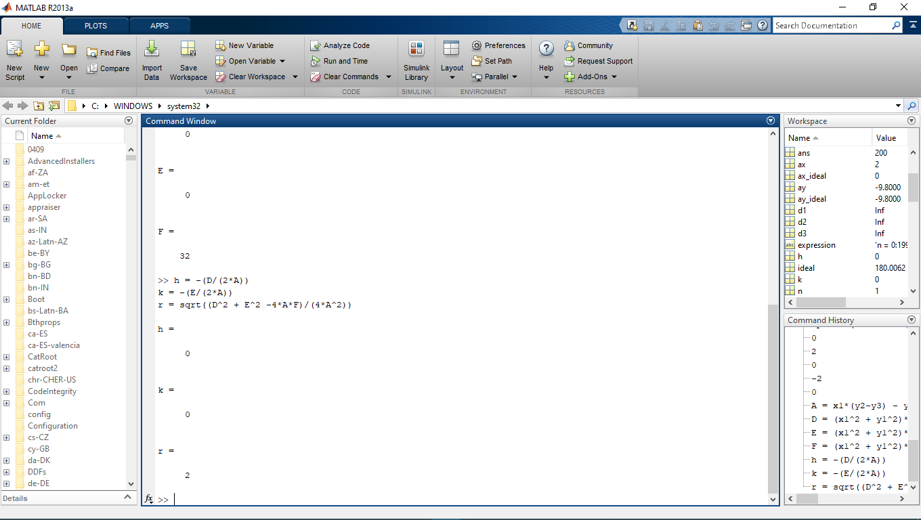

**Print results.**

**Finding the center, (h,k) and  
radius r**